# Publishing your Website.

So now that you have created your website you want to publish it as wide as you can and make sure that you submit It to as many relevant search engines as possible and there are some search engines that can do that for you such as:

* Google search console
* Bing Webmaster tool
* DuckDuckGo
* Yandex
* Wiki

Well most of the search engines have their own webmaster tools in order to help you to manage your website and your website presence on the web; however there are two search engines that you will need the most are:

* Google search console
* Bing Webmaster tool

First of all starting with the set up of Google search console:

* Before we will be able to submit your website to Google, at first you’ll have to establish a search console account and then you have to verify your ownership. The best to use your Gmail account for this one.

If you manage more than one website domain, you will have the ability to manage them all form the same account. Once your account is set up, check to follow Google’s tips on verifying your website property. There is going to be some prompts that will help and provide you with multiple options to verify your website. Also if your account is the same as your Analytics account, your website will be auto- verified.

Setting up Bing Webmaster tools

* The first step to do is to set up an account. Bing makes this step easy by permitting you to sync your existing email accounts to quickly create a Bing Webmaster tools profile, once your are logged in and done the procedure to Bing’s Webmaster tools , you are ready for the next step of submitting your website(submit a sitemap in Bing webmaster tools),Also to submit your site to yahoo, you don’t have to do anything because Yahoo is powered by Bing’s index, that means that by submitting to Bing, your site will be automatically submitted to Yahoo. and there are some certain aspects that Bing performs better than Google, for starters Bing has a reward programs that allows the person to gain point for searching and then these points are redeemable at Microsoft and windows stores which is a nice feature.
* Now I am going to present the stats regarding the most used search engines.

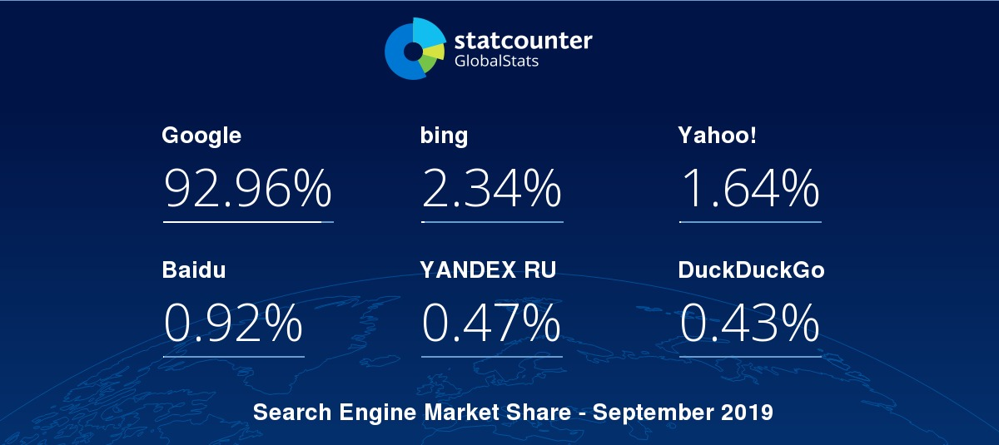



# References

* Search Engine Journal. (2019). *How to Submit Websites & Pages to Search Engines: A Simple Guide*. [online] Available at: https://www.searchenginejournal.com/submit-websites-webpages-search-engines/296253/#close [Accessed 28 Oct. 2019].
* Search Engine Journal. (2019). *14 Great Search Engines You Can Use Instead of Google*. [online] Available at: https://www.searchenginejournal.com/alternative-search-engines/271409/#close [Accessed 28 Oct. 2019].
* StatCounter Global Stats. (2019). *Search Engine Market Share Worldwide | StatCounter Global Stats*. [online] Available at: https://gs.statcounter.com/search-engine-market-share/all/worldwide/2016 [Accessed 28 Oct. 2019].
* StatCounter Global Stats. (2019). *StatCounter Global Stats - Browser, OS, Search Engine including Mobile Usage Share*. [online] Available at: https://gs.statcounter.com/ [Accessed 28 Oct. 2019].